|  |  |
| --- | --- |
| Date | 08 October 2022 |
| Team ID | PNT2022TMID03254 |
| Project Name | Intelligent Vehicle Damage Assessment and Cost Estimator for Insurance Companies |
| Maximum Marks | 2 Marks |

Step-1: Team Gathering, Collaboration and Select the Problem Statement

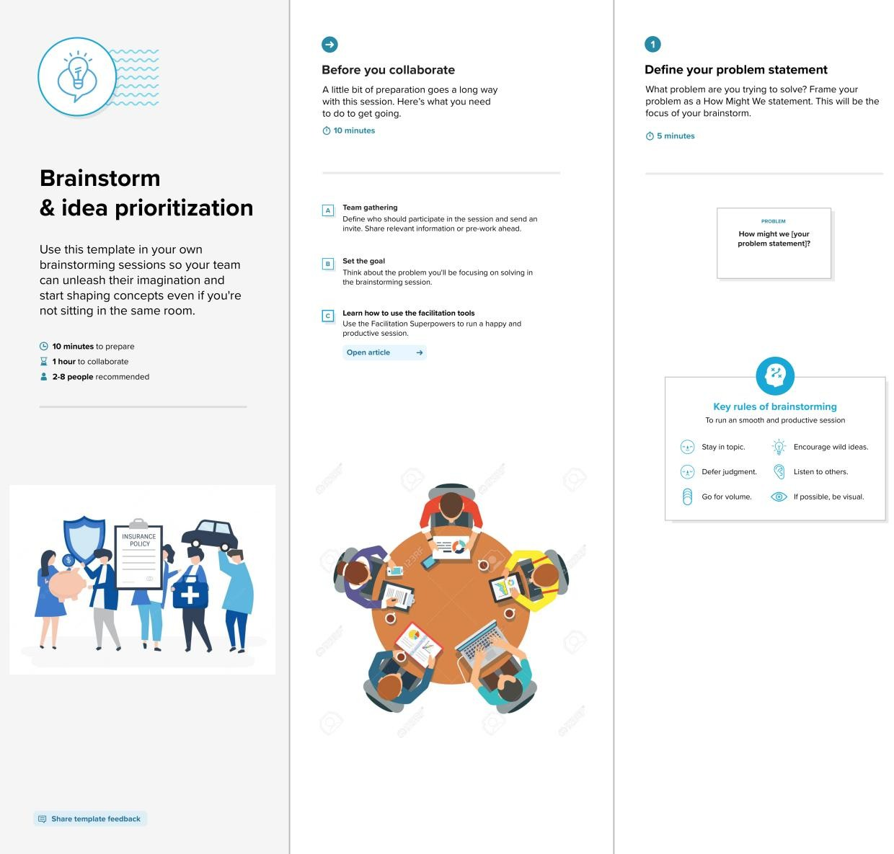

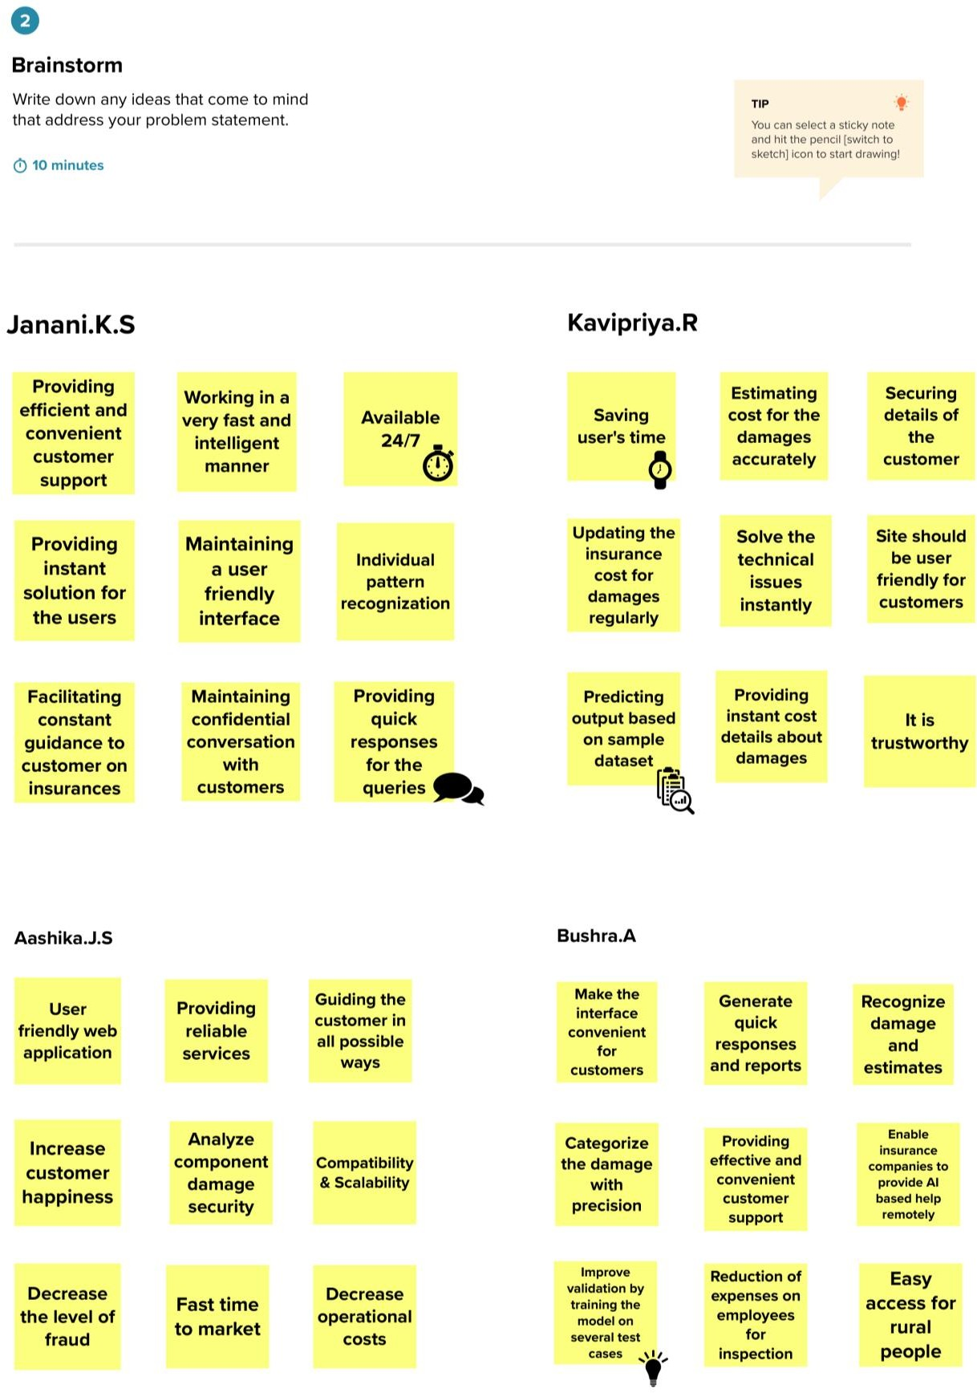Step-2: Brainstorm, Idea Listing and Grouping

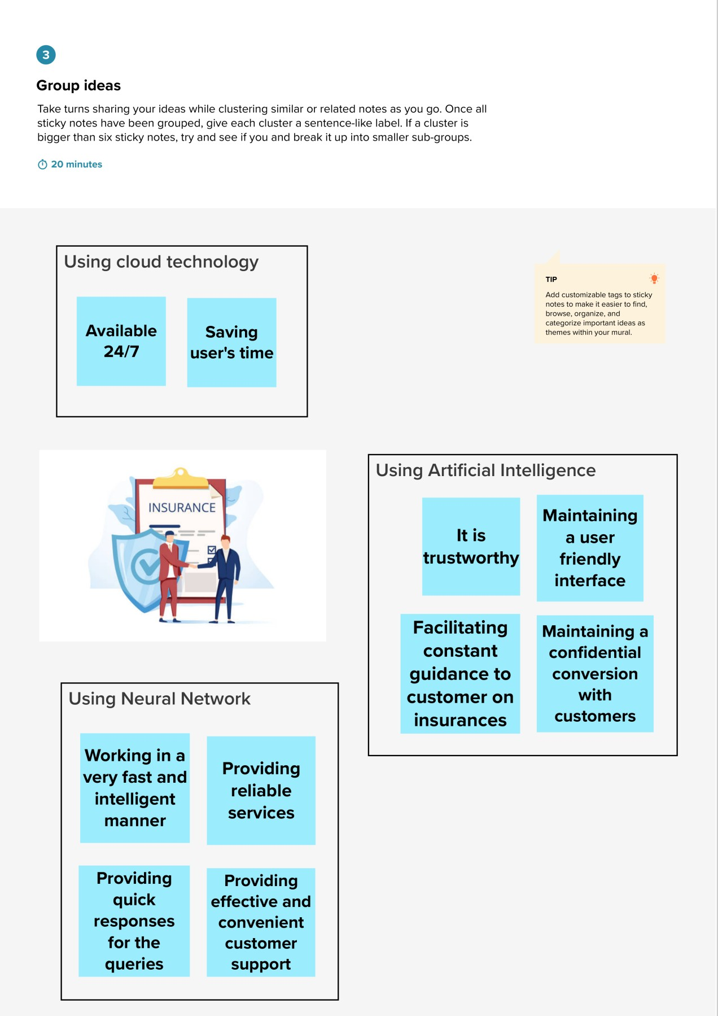

Step-3: Idea Prioritization

